**Project Planning Phase**

**Project Planning Template (Product Backlog, Sprint Planning, Stories, Story points)**

|  |  |
| --- | --- |
| Date | 26 June 2025 |
| Team ID | LTVIP2025TMID20451 |
| Project Name | EduTutor AI: Personalized Learning with Generative AI and LMS Integration |
| Maximum Marks | 5 Marks |

**Product Backlog, Sprint Schedule, and Estimation (4 Marks)**

Use the below template to create product backlog and sprint schedule

| **Sprint** | **Functional Requirement (Epic)** | **User Story Number** | **User Story / Task** | **Story Points** | **Priority** | **Team Members** |
| --- | --- | --- | --- | --- | --- | --- |
| **Sprint-1** | **Registration** | **USN-1** | **As a user, I can register using a username and password.** | **2** | **High** | **Indu,Srivani** |
| **Sprint-1** | **Registration** | **USN-2** | **As a user, I can log in to my account with name and password.** | **2** | **High** | **Indu** |
| **Sprint-1** | **Session Tracking** | **USN-3** | **As a user, I can track my sessions after login.** | **2** | **Medium** | **Srivani** |
| **Sprint-1** | **Concept Understanding** | **USN-4** | **As a user, I can enter a concept and get AI-generated explanation.** | **3** | **High** | **Indu** |
| **Sprint-1** | **Language Learning** | **USN-5** | **As a user, I can choose Hindi or English and learn grammar basics.** | **3** | **High** | **Srivani** |
| **Sprint-2** | **File Upload & Quiz Generator** | **USN-6** | **As a user, I can upload a PDF and receive a quiz based on the content.** | **5** | **High** | **Indu** |
| **Sprint-2** | **Topic-Based Quiz** | **USN-7** | **As a user, I can enter a topic and receive a custom quiz.** | **3** | **Medium** | **Srivani** |
| **Sprint-2** | **Gradio UI Setup** | **USN-8** | **As a developer, I can create a multi-tab UI using Gradio.** | **3** | **High** | **Indu** |

**Project Tracker, Velocity & Burndown Chart: (4 Marks)**

| **Sprint** | **Total Story Points** | **Duration** | **Sprint Start Date** | **Sprint End Date (Planned)** | **Story Points Completed (as on Planned End Date)** | **Sprint Release Date (Actual)** |
| --- | --- | --- | --- | --- | --- | --- |
| Sprint-1 | 10 | 5 Days | 15 June 2025 | 19 June 2025 | 10 | 19 June 2025 |
| Sprint-2 | 16 | 5 Days | 20 June 2025 | 24 June 2025 | 16 | 24 June 2025 |

Imagine we have a 5-day sprint duration, and the velocity of the team is 13 (points per sprint). Let’s calculate the team’s average velocity (AV) per iteration unit (story points per day)

**AV = sprint duration / velocity = 13 / 5 = 2.6**

**Burndown Chart:**

A burn down chart is a graphical representation of work left to do versus time. It is often used in agile[software development](https://www.visual-paradigm.com/scrum/what-is-agile-software-development/) methodologies such as [Scrum](https://www.visual-paradigm.com/scrum/scrum-in-3-minutes/). However, burn down charts can be applied to any project containing measurable progress over time.

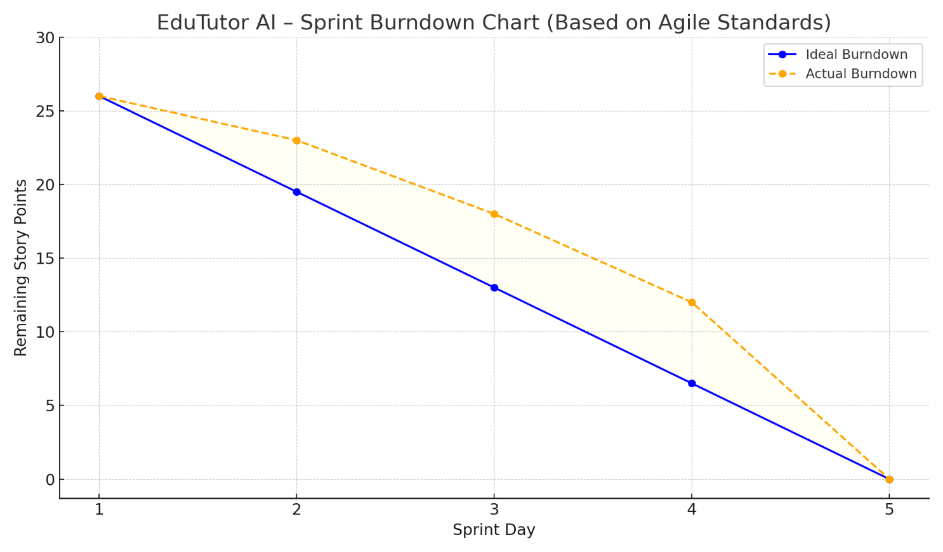

[**https://www.visual-paradigm.com/scrum/scrum-burndown-chart/**](https://www.visual-paradigm.com/scrum/scrum-burndown-chart/)

[**https://www.atlassian.com/agile/tutorials/burndown-charts**](https://www.atlassian.com/agile/tutorials/burndown-charts)